To the world now in technological surrounding we might fall with things that technology create but first we need to understand technology is not just giving us comfort and luxury it is to make our life simple and make world sustainable through product relate to climate change .

Today too many technology industries were gather to mitigate climate change problem .one of them is IEEE , it is multinational company working on climate change producing a good for sustainable life.

From back then 19s to 21st,30 to 40 yrs Aral sea collapsed it is big threat that we know how important sea is for earth . Our climate is hugely affected by sea traits , it is big indicator not just resource. Our climate is big time influence by sea and atmosphere around it .it cover huge atmospheric environment and now Aral sea is vanished .It is not just we loose one sea resource but environment around their is certainly affected and that’s a problem.

With growing climate warmth of around 0.5% , scientist were get their heart beat pump faster ,with this stuff we have no answer what it cause to us.

Just let ideas meet the cause and start to solve this problematic situation.

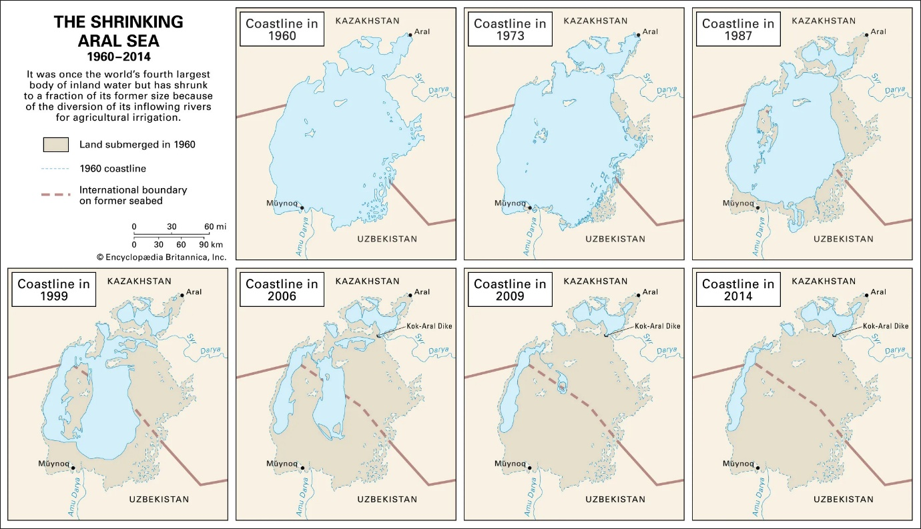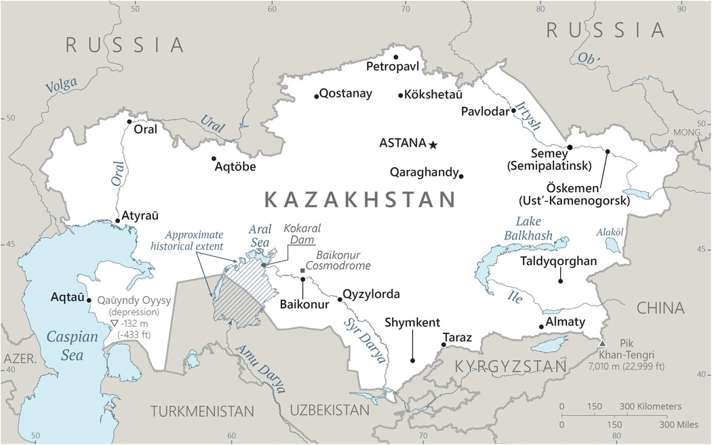

Aral sea this is not just a disappeared one but , a very crucial issue created by human civilization .Basically it is a source used for many environmental purposes .

No 1. Water supply.

No 2. Tree life

No 3. Atmosphere

No 4. Carbon processing

No 5. Oxidisation

No 6. Other natural and environmental

So, human doesn't loss just a means of irrigation and industry use that with this source mainly Russia do.Human found too many problem due we loss a huge source of natural resource can use for human directly and indirectlNow Aral sea is just in map and little procedure happen to save it but it already too late to see it natural easily. We must work hard to get our life back

Too high use of this water source is the main reason we lost our back utility.Concern is should we get back what we loss? And mitigate climate change issue which is the agenda of this paper.